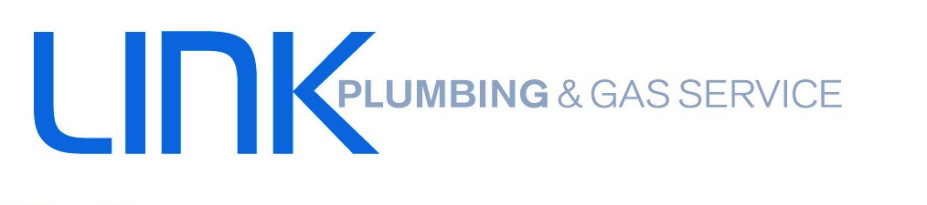
www.linkplumbing.net.au
admin@linkplumbing.net.au
08 6252 0326
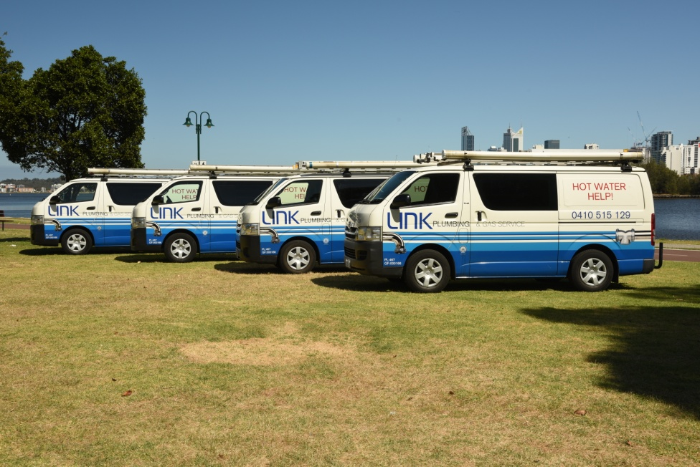
To provide quality workmanship and a welcoming environment, where we continuously exceed the increasing expectations of our customers.
Link Plumbing and Gas Service is a WA owned and run plumbing company that has been servicing the Perth metropolitan area for over 30 years.
We specialise in servicing and installing all Hot Water units and offer advice for the one to suit your premises. Call us today on 08 6252 0326.
